16.24: Open Pipe:

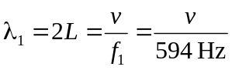

Closed at one end:
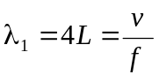
Taking ratios:
